# **Travelling Sales Person problem**

Back-tracking and Branch and Bound are similar. They use the same state space tree.

**Back-tracking** 🡪 Used to solve permutations and combination problems. This will give solution to all the paths and from that we should find the minimum. So Time consuming and cost is extremely maximum.  
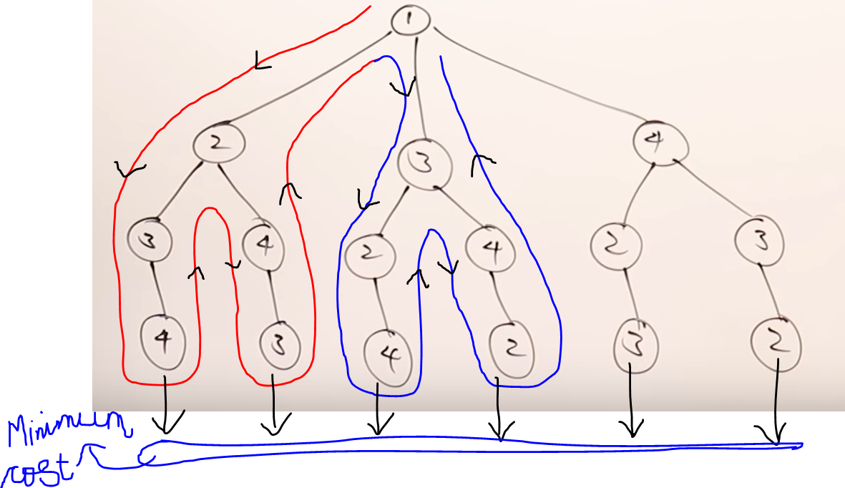

**Brach bound** 🡪 Used to solve optimization problems (i.e minimization / maximization)

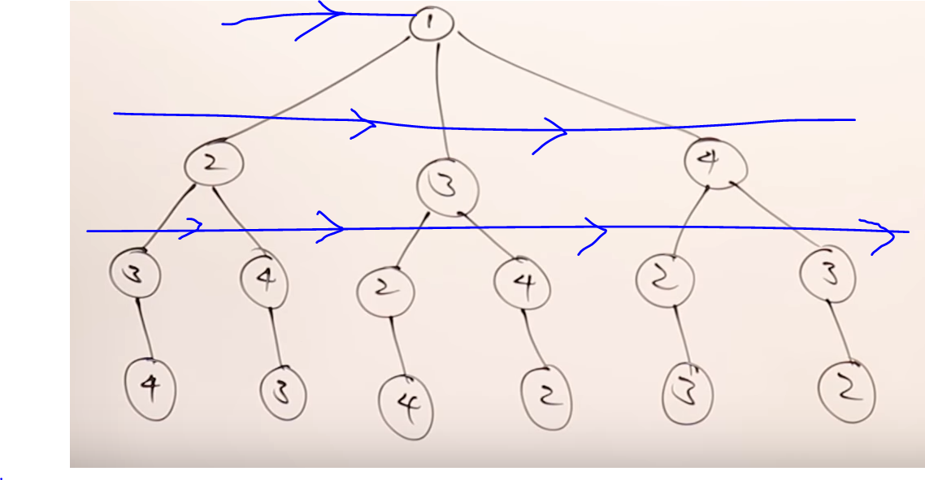

In the 2nd row, will find the minimum between vertex-2,3,4. If the cost of traversing the nodes is minimum at vertex-3, then we will discard the remaining the vertices-2 and 4. So there is no need of going into vertex-2 and vertex-3 and its child.  
So Time consuming and cost is extremely minimum and low.

Question

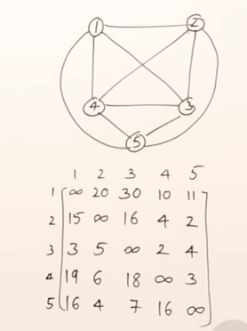

Step-1 Reducing the row

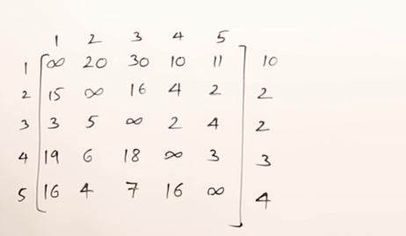

Reduce the row

After subtraction  
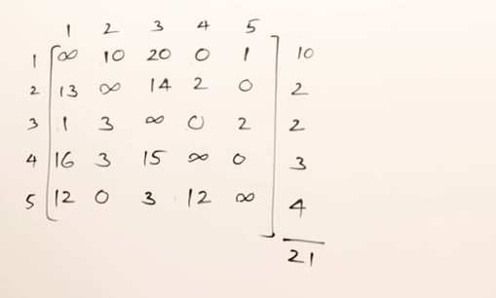

Now reduce the columns

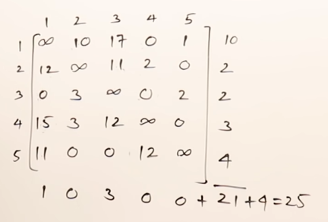  
This is the reduced matrix and the cost of reduction 🡪 25.

***Now, at-least the cost of the tour is 25.***

**From Node-1 to Node-2**

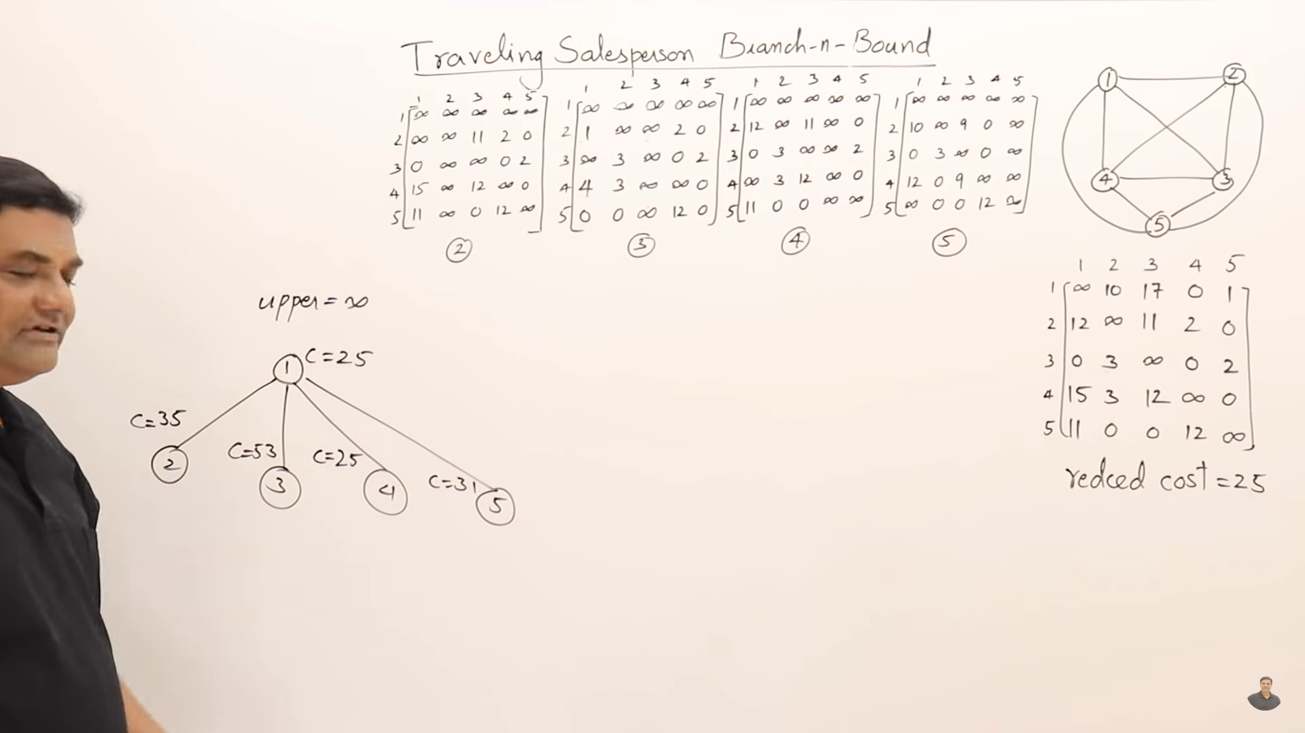

If we start exploring from vertex-2,3,4,5. Then we are following  
***first-first out branch and bound***. But we want optimal solution.  
So we are going to use ***Least Cost branch and bound***.

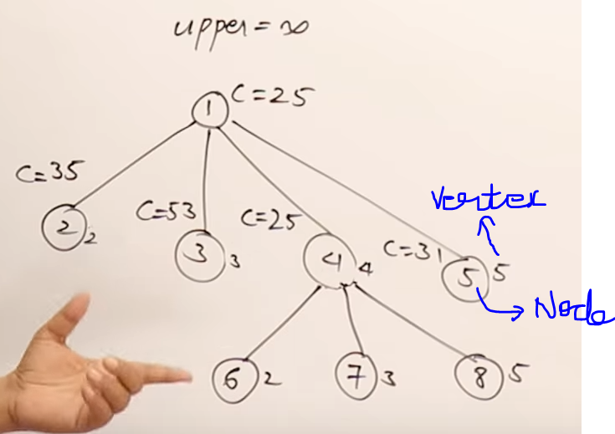

In 1st row (35,53,25,31) 🡪 25 is minimum.   
Now we want to find (4 to 2 , 4 to 3 , 4 to 5) by taking the matrix-4.

Vertex-4 to Vertex-2 ( from 2 to 1 🡪 inf )  
Vertex-4 to Vertex-3 ( from 3 to 1 🡪 inf )  
Vertex-4 to Vertex-5 ( from 5 to 1 🡪 inf )

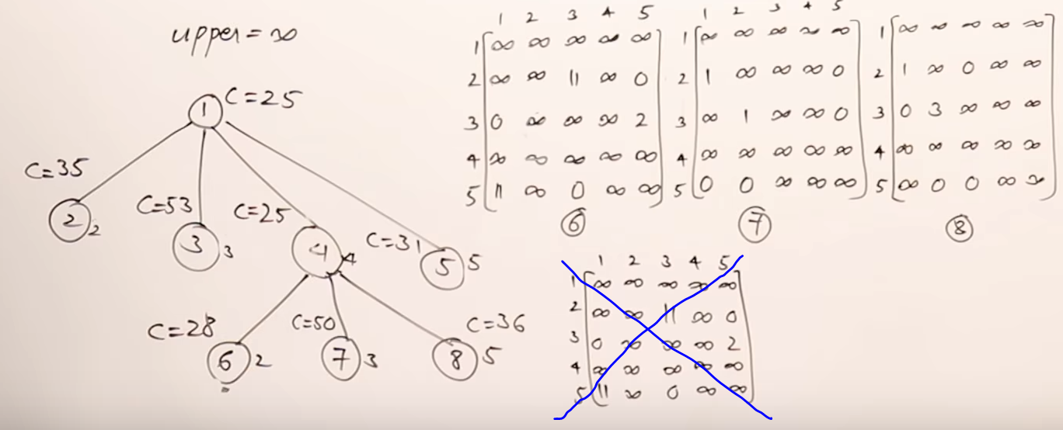

In 2nd row (28,50,36) 🡪 28 is minimum.   
Now we want to find (2 to 3, 2 to 5)by taking the matrix-6 (i.e vertex-2).

Vertex-4 to Vertex-2 ( from 2 to 1 🡪 inf )  
Vertex-4 to Vertex-2 ( from 2 to 1 🡪 inf )

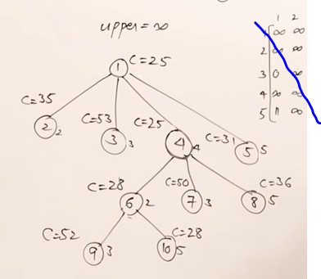 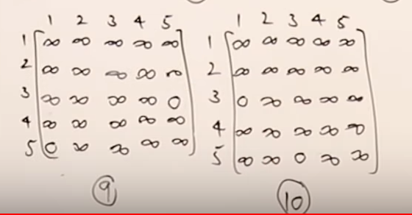

In 3rd row (52,28 ) 🡪 28 is minimum.   
Now we want to find (5 to 3)by taking the matrix-10 (i.e vertex-3 ).  
Since the vertex-3 is only remaining.

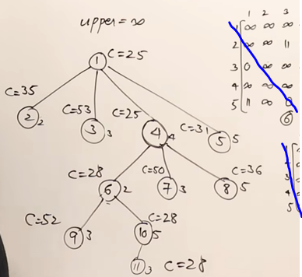

Now we got the final graph. (1 🡪 4 🡪 2 🡪 5 🡪 3 and then to 1)   
The final cost=28.

